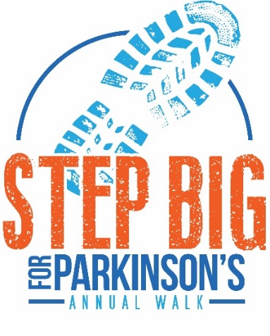
Frequently Asked Questions

- When does online registration end?
  - Last day for online registration will be Tuesday, August 1st. You can still register at the event between 8:00am – 9:00am on Saturday, August 5th at Jefferson High School.

- When will I get my shirt and packet?
  - You will be able to pick up your t-shirt and packet the week before the walk…stay tuned for specific dates/times.
  - You can also pick up the day of the walk at the registration table.

- How far is the walk?
  - Participants can choose their distance! Feel free to walk one lap or multiple laps around the track.

- Where do my dollars go/how do they help?
  - Your registration fee and fundraising dollars stay in South Dakota, helping improve the quality of life for people living with Parkinson’s disease. Your dollars will help the SD Parkinson Foundation provide resources, networking opportunities, and support for people within our state. Help us help them!

- Do I have to show up to receive a walk t-shirt?
  - T-shirts are for walk or virtual walk participants only. If you register as a walk participant but are unable to attend the event, your shirt will be mailed to you or you can pick up at a later date…please contact the SDPF office.

- What does it mean to be a virtual participant?
  - By virtually participating in the walk, you can join our community of support from wherever you are! You don’t have to walk on the exact walk date either…just gather friends and family and enjoy time spent together.

- What activities are at the walk event?
  - A bouncy house, outdoor games, and face painting will be available for kids, along with informational exhibitors for adult participants.

- Will there be food at the walk?
  - There will be a light brunch served after the event. Muffins, fruit, granola bars, coffee, water, and juice will be available.

- Do I have to walk at the event?
  - No - One of the main reasons we host the Step Big Walk at Jefferson High School is so participants can enjoy the event by cheering their friends and families on from the bleachers as they walk around the track!

- Is this a family-friendly event?
  - Yes - We encourage you to bring friends and family!

