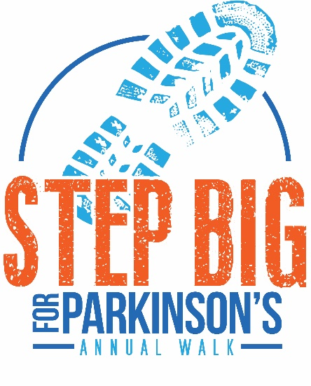

Participant’s Name

Team Name
Participant Pledge Form

COLLECTED

FLAT DONATION
SPONSOR’S NAME
ADDRESS

Ex: John Smith | Ex: 1234 Main Street, Anytown, FL, 12345 | Ex: $50.00 | Ex: $50
COMPANY MATCHING DONATION
(Please include necessary forms.)
This individual is participating in and raising funds for the local
Step Big Walk for Parkinson’s.
Our goal is for each walker to raise a minimum of $100.

TOTALS

