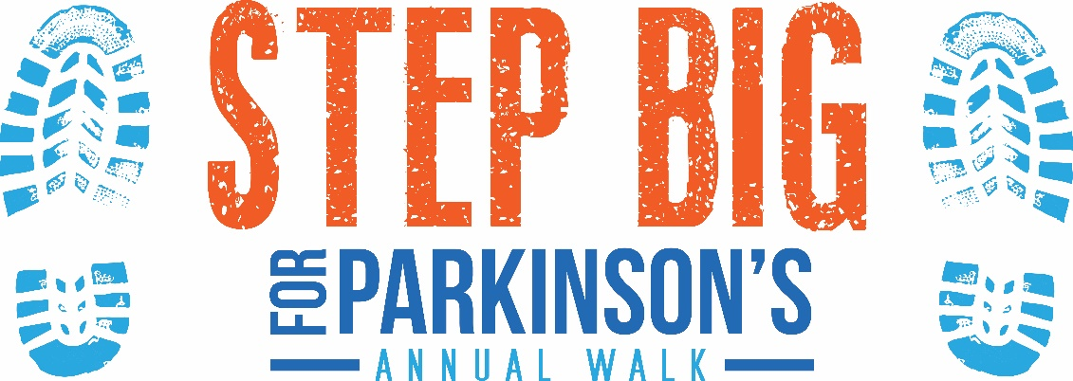

How to Raise $500 in 10 Days
Day 1: Register yourself for $35

Day 2: Ask five family members to donate $20 each.

Day 3: Ask five friends to contribute $20 each.

Day 4: Ask five co-workers to contribute $10 each.

Day 5: Ask five neighbors to contribute $10 each.

Day 6: Ask five people from your place of worship to contribute $10 each.

Day 7: Ask your boss for a contribution of $50.

Day 8: Ask two businesses or companies that you deal with through work to sponsor you for $25 each

Day 9: Ask businesses you frequent to personally contribute $15.
(hair salon, dry cleaner, coffee shops, gym, dentist, doctor, local grocery store, etc)

Day 10: Hold a team fundraiser
(bake sale, raffle, car wash, rummage sale, jeans day, etc.)

www.southdakotaparkinson.org
***Click under EVENTS tab***

