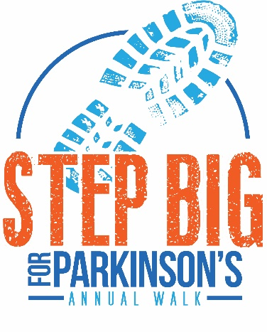
Dear Family & Friends,
I have committed to walking in the 2023 Step Big Walk for Parkinson’s on Saturday, August 5th. I’m asking for your support to help me in reaching my fundraising goal. All funds raised remain in the state of SD and go to support the South Dakota Parkinson Foundation (SDPF), a foundation working towards their mission to improve the quality of life for those touched by Parkinson’s disease.
Please join me in helping support those living with Parkinson’s disease by making a donation. You can donate online by visiting the South Dakota Parkinson Foundation website at www.southdakotaparkinson.org and clicking under the EVENTS tab or by filling out the enclosed envelope and mailing to the local SDPF office (1000 N West Ave, Suite 220, SF, SD 57104).
Your friendship and support means a lot to me. Together, we are making a difference one day at a time for individuals living with Parkinson’s disease, their caregivers and family members.
Sincerely,

Dear Family & Friends,
I have committed to walking in the 2023 Step Big Walk for Parkinson’s on Saturday, August 5th. I’m asking for your support to help me in reaching my fundraising goal. All funds raised remain in the state of SD and go to support the South Dakota Parkinson Foundation (SDPF), a foundation working towards their mission to improve the quality of life for those touched by Parkinson’s disease.
Please join me in helping support those living with Parkinson’s disease by making a donation. You can donate online by visiting the South Dakota Parkinson Foundation website at www.southdakotaparkinson.org and clicking under the EVENTS tab or by filling out the enclosed envelope and mailing to the local SDPF office (1000 N West Ave, Suite 220, SF, SD 57104).
Your friendship and support means a lot to me. Together, we are making a difference one day at a time for individuals living with Parkinson’s disease, their caregivers and family members.
Sincerely,

